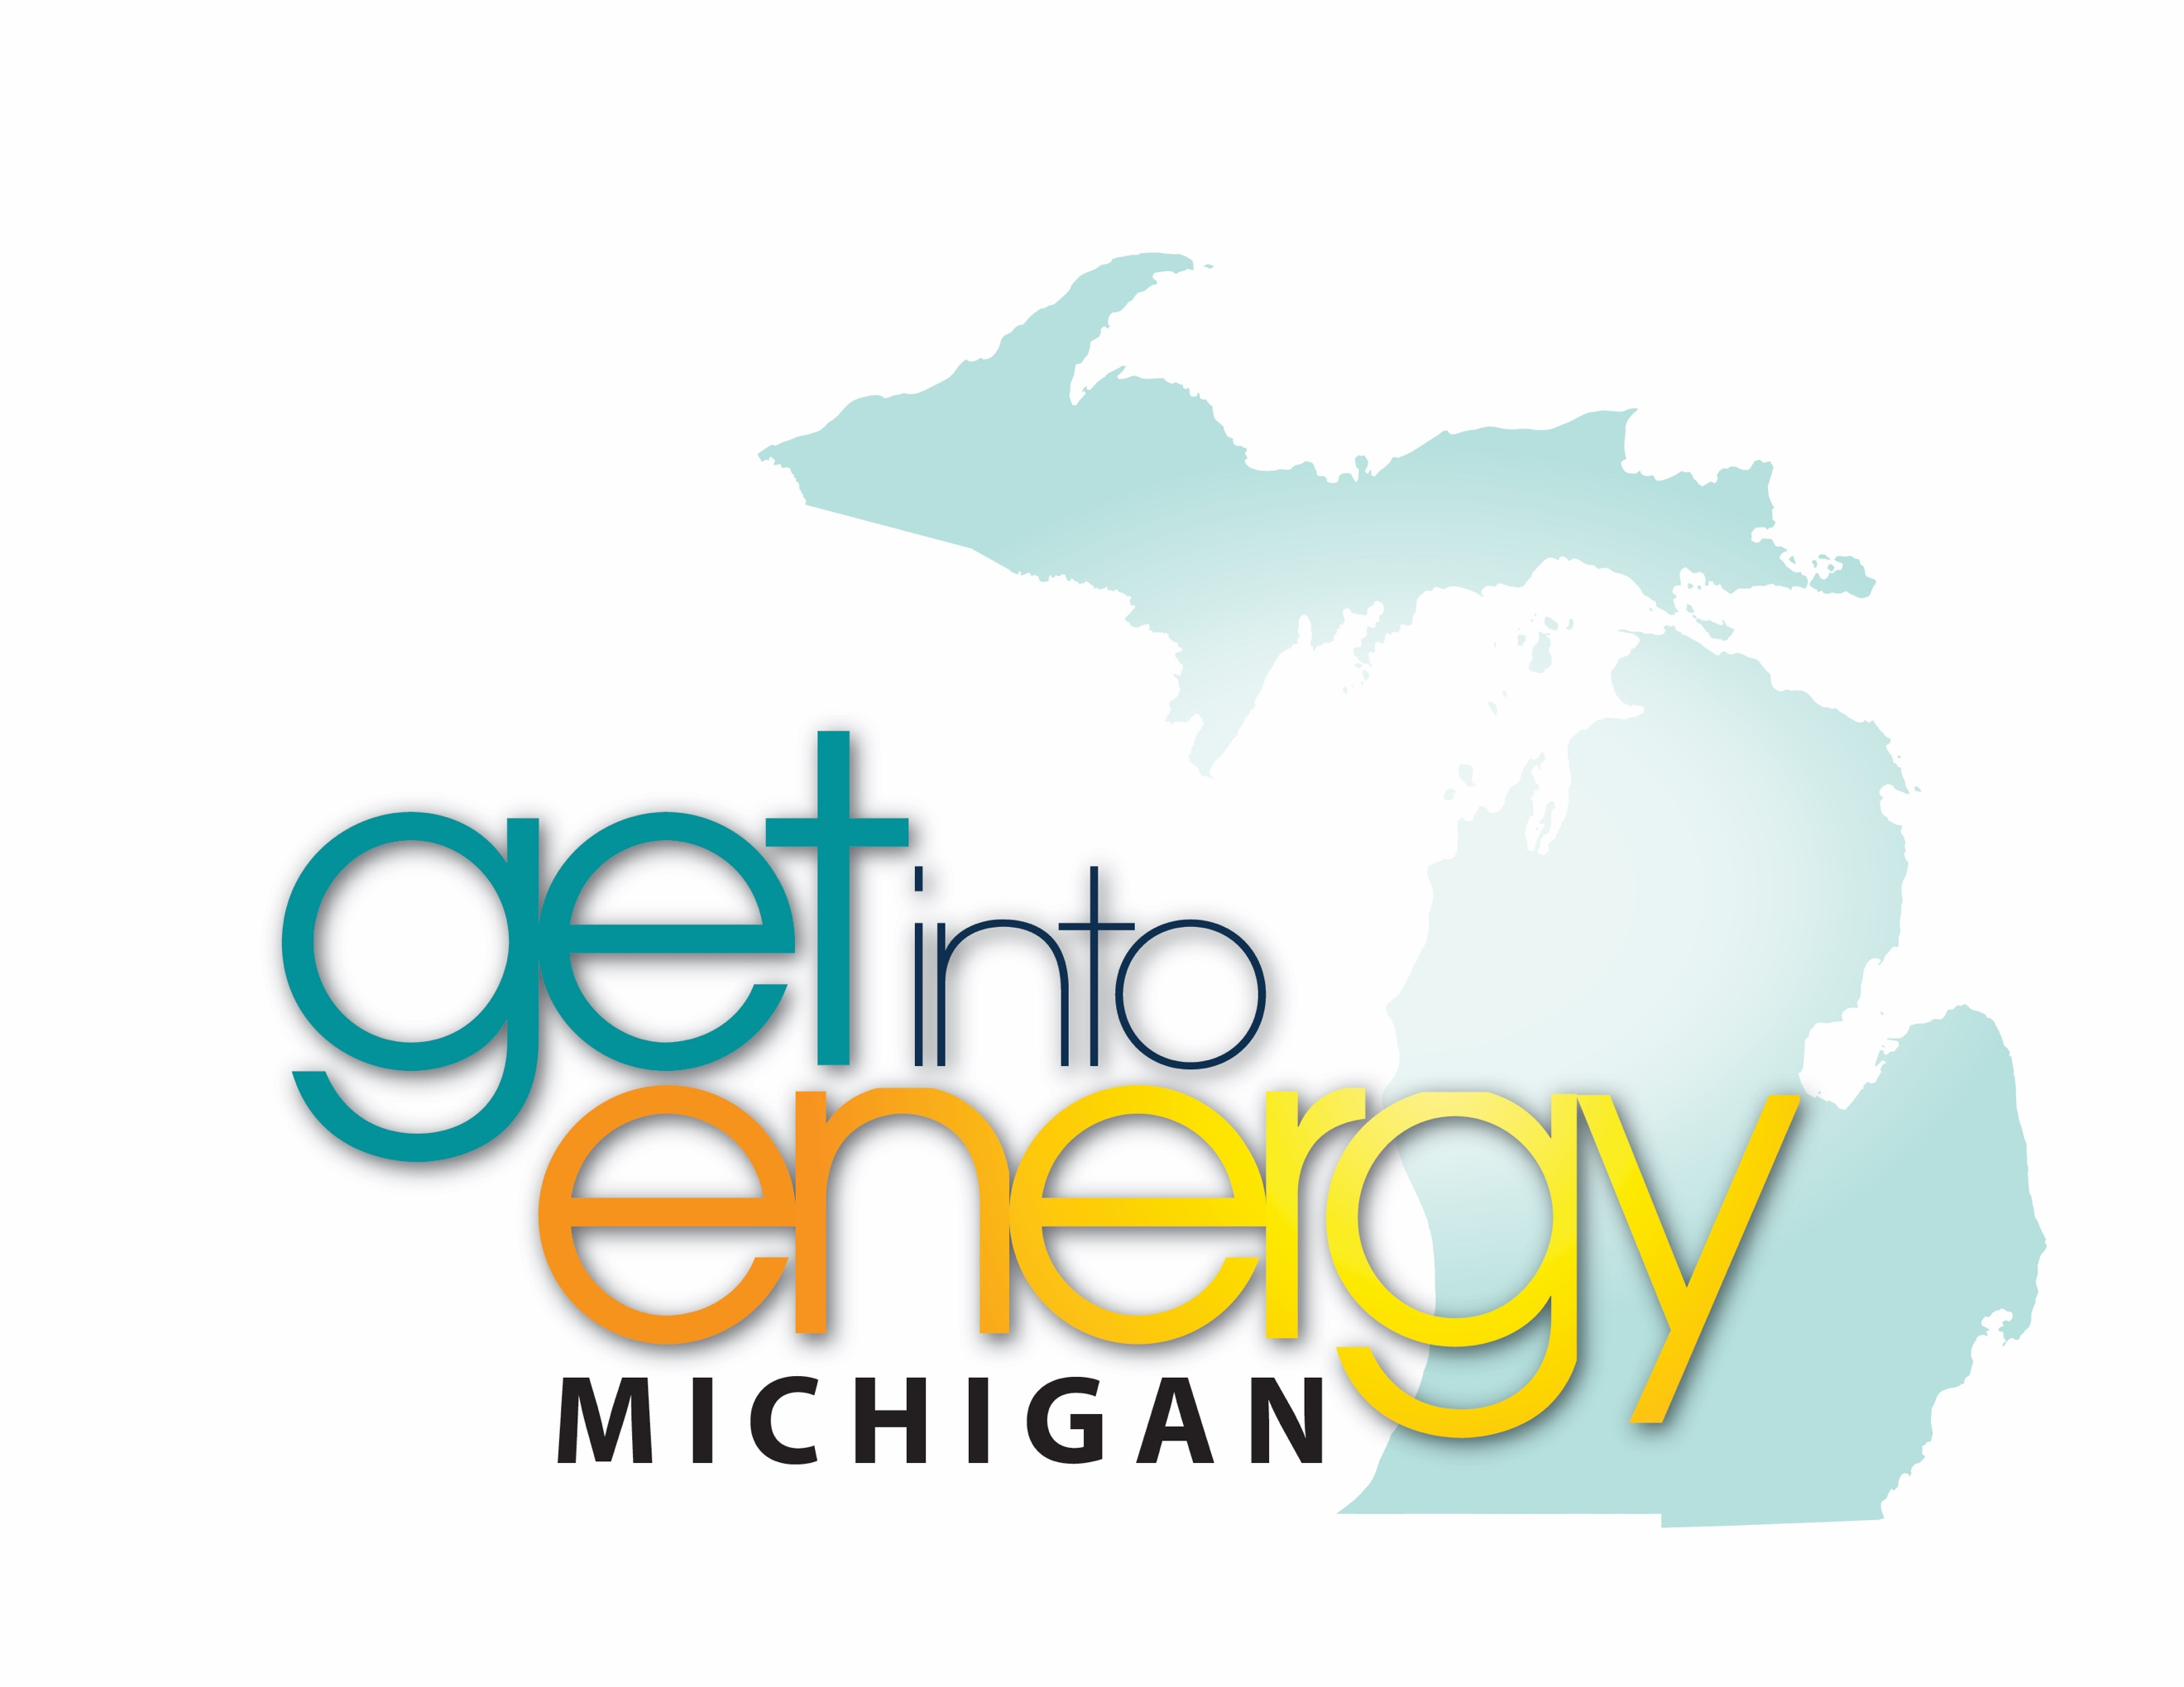
Careers in Energy
Week 2019

High School Energy Careers
Trivia Contest

Rules:
- The contest promotes Careers in Energy Week, Oct. 14-18, 2019 and is open to all Michigan high school students (9-12).
- All submissions must be made using the Google Form provided no later than 9 p.m. Sunday, October 20. Only entries using this form will be accepted.
- Contestants must answer each day’s question correctly to be eligible for the prizes.
- Seven winners will be selected randomly from all qualifying entries.
- Each winner will receive:
  - $100 Amazon Gift Card
  - Holy Stone F181G Drone with camera
  - $250 for their attending school

How the contest works:
- Contest begins 6 a.m. Monday, October 14. Each day (Monday through Friday), a question will be posted to the consortium website (www.CareersInEnergyMichigan.com). Students will visit that site to get the question each day. They will keep a running list of their answers throughout the week and submit one form on Sunday.
- Using the 2019 Careers In Energy Week contest submission form (Google form hyperlink), students will submit their answers for the entire week no later than 9 p.m. Sunday, October 20.
- Teachers are encouraged to use the daily questions as an opener, or quick activity in their class to promote energy career awareness. Students will need computer access to complete the daily task.
- Some questions will be open-ended and multiple responses will be accepted.
- Once the submission deadline closes, seven random winners will be chosen from all qualifying entries. Winners will be notified no later than Friday, October 25, and prizes will be issued no later than November 22.

