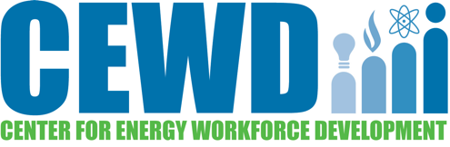

Strategic Alliances

National Associations
American Association for Blacks in Energy (AABE)
U.S. Chamber of Commerce/Institute for Workforce Competitiveness

National Education/Workforce Associations
American Association of Community Colleges (AACC)
American Council on Education (ACE) Division for Lifelong Learning
Association for Career & Technical Education (ACTE)
National Association of Workforce Boards (NAWB)
National School Boards Association (NSBA)

National Government Agencies
Department of Defense
Department of Education, Office of Career, Technical & Adult Education
Department of Energy
Department of Labor’s Education & Training Administration
Department of Labor’s Veterans & Employment Training Service/Hire Vets First

Secondary
FIRST®
SkillsUSA

Veterans
Academy Women
Credit2Careers
PsychArmor
Soldiers to Sidelines

Women
Academy Women
Energetic Women
Society of Women Engineers (SWE)

